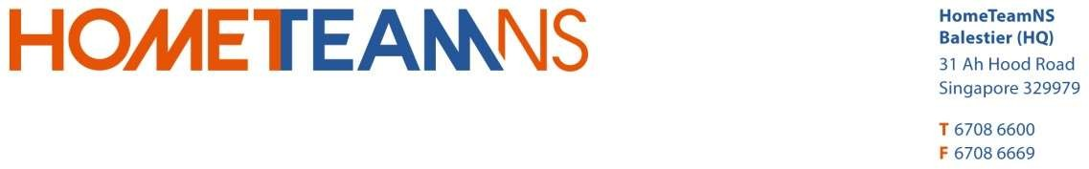

To whom may concern,

LETTER OF AUTHORIZATION

(For checking-in)

|  |  |
| --- | --- |
| MEMBER’S BOOKING | AUTHORSATION GUEST |
| Member’s Name:  NRIC No. : (last 4 character eg. 123A) Contact No. : | Guest Name:  NRIC No. : (last 4 character eg. 123A) Contact No. : |

Villa Unit No. : _

Date of Check-in : _ (Time from: 3pm – 6pm) Date of Check-out : _ (Time from: 9am – 10am)

I, hereby authorize the above (Guest) to check-in into the villa on my behalf on the date above.

** I do understand that HomeTeamNS will need to verify this letter upon check-in. (Please tick where applicable.)

1. You may contact me, upon check-in .
2. I am unable to be contacted for verifying this letter upon check-in.

# (Please take note, member are required to proceed *personally* to Villa Concierge for verification *before* the booking date).

i) Verified by HomeTeamNS Staff

(Only original copy letter upon check-in)

# I acknowledge that if this letter is not verified, my guests are not allowed to check-in.

Sincerely yours,

Member’s Signature

HTNS-SYSTEM-07-25